Chapter 17, Solution 55.

T = 2π, ω_{o} = 2π/T = 1

c_{n} = 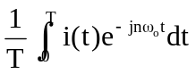

But i(t) = 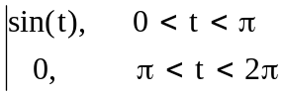

c_{n} = 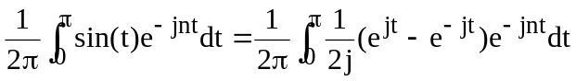

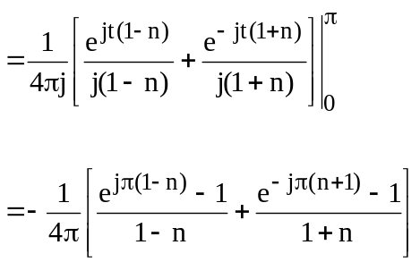

But e^{jπ} = cos(π) + jsin(π) = –1 = e^{–jπ}

c_{n} = 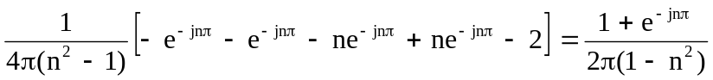

Thus

i(t) = 